Contents

Import the database 2

Initialize the DB 6

Uploading the HMS system to the server / hosting 8

Dashboard 11

Page Settings 11

Change Currency 12

Hotel Config -> seasons 13

Hotel Config -> Agents 14

Hotel Config -> meal plan 16

Room -> Room Category 16

Hotel Config -> Agent Room Rates 18

Hotel Config -> Guests 19

Hotel Config -> Unit Name 20

Rooms - > Room Type 20

Room -> Rooms 21

Rooms -> facilities 23

Room -> Booking 24

Room - > Reservation 28

Adding a reservation directly 28

Convert a booking to reservation 29

Show overlapping bookings when adding a reservation 31

Reservation EDIT 36

Check-in Reservation 38

Add manual bill to reservation bill 39

Printing bills 42

Reserved Status 42

Checked IN Status 42

Checkout Reservation 43

Reports 45

Daily Forecast 45

Print Forecast 46

Room Forecast 47

Print room forecast 49

Stage 1 (Deployment)

# Import the database

This system needs a MySQL server to host the database, after configuring the MySQL server create a new database with your preferred name and also assign a user to do the crud operations in the database (please get assistant from your network administer for this step)

The network administer will provide you’re the database name and some user credentials, keep them safe and do not expose them to any other personal. (These credentials should be added to the Evolve hotel management system to work so please keep them in safe easily accessible place to you)



Figure 1 the database created from the hms system

Then import the sql file provide by evolve team to the database. Below are the steps

Step.1 -> click on your database name and window will be open as below image

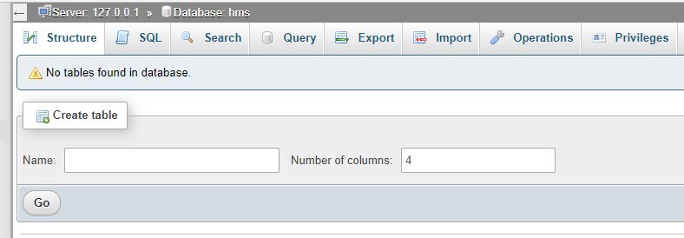

Figure 2 empty database

Step 2 -> Click on import on the top menu

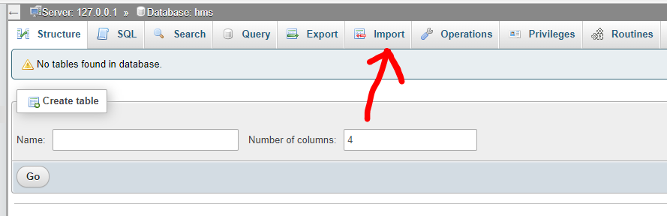

Figure 3 import button click

Then a page like below will appear as below, click on choose file, a browsing window will be open to locate the sql file, navigate to the place where your sql file(provided by evolve team) and select it then click on open.

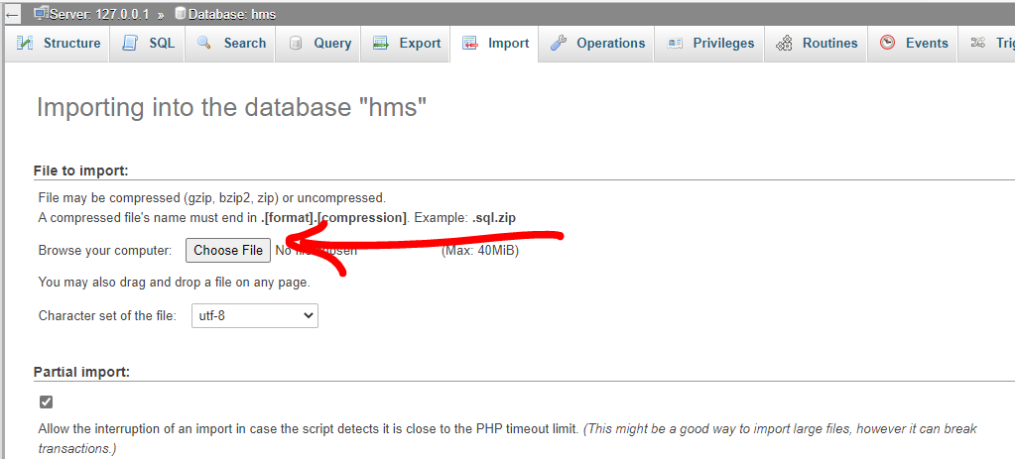

Figure 4 importing the db step 1

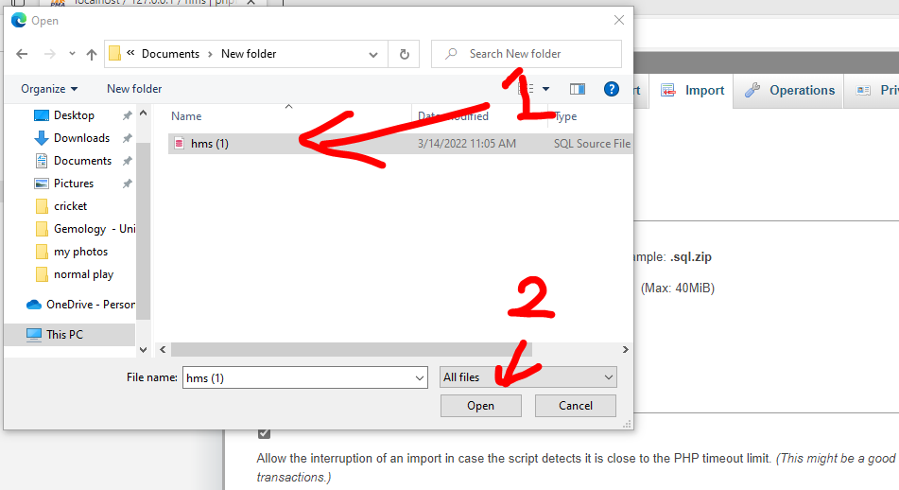

Figure 5 select and open sql file

Then the popup window will be closed, then scroll down the page and click on the go button. The

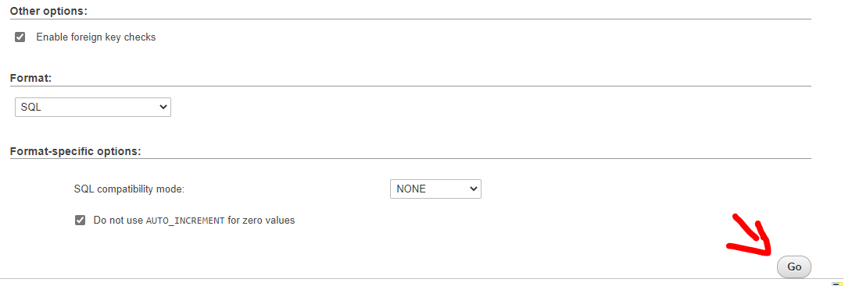

Figure 6 click on go

This will setup the required tables which is used by the hotel management system, if in any case if something went wrong, please contact your network administer or evolve team.

If importing was successful then a success message will be shown and when you refresh the page you will see the tables in your database as below.

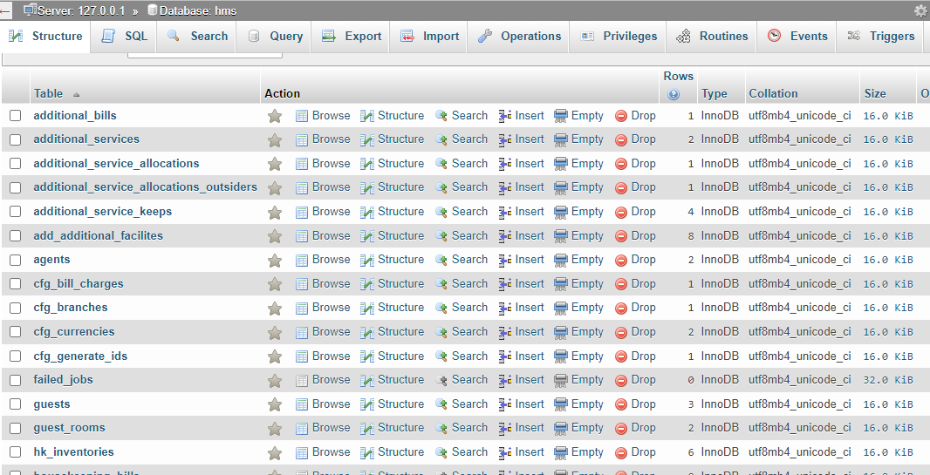

Figure after importing the tables to the database using sql file

# Initialize the DB

Before proceeding with the system, the are few things to be initialized in the database, if not the system won’t work as expected

table 1 =>

(Please note that this step in not compulsory, if you need to add a extra charge to a bill like service charge for the room bill then follow below steps or else skip this step)

go to the  [cfg_bill_charges](http://localhost/phpmyadmin/index.php?route=/sql&db=hms&table=cfg_bill_charges) table, this table is responsible for holding the extra charges regarding the bills, for example hotel service charge rate should be inserted to this table so that to bills like final room bill will be calculated with the service charge rate that you added.

Steps => go to insert tab on the top menu and a page as below will be shown. Add the related information in the input fields as shown below (keep bill_charge_id, created_at, updated_at, columns empty).

please remember that rate column the rate should be inserted as percentage, (E.g: if you need to add 5% to the final room bill in your hotel then add 5 in the rate input field). Then click on go to insert the record to the table. Please repeat the above steps if you need to add more charges to the final bill.

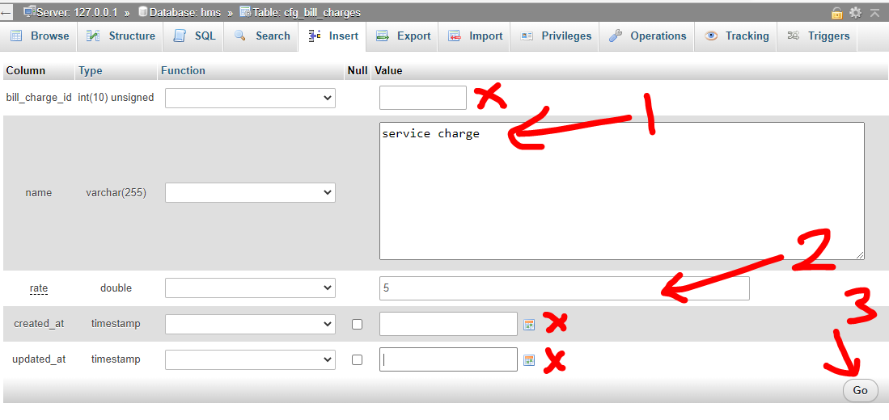

Figure 8 insert the bill charges

Then the record will be shown as below



Figure 9 charges in the table

Table 2 = > it is compulsory to initialize [cfg_branches](http://localhost/phpmyadmin/index.php?route=/sql&db=hms&table=cfg_branches) table which holds the branches of the hotel, this table should be configured before adding users to the users table because each user should have a branch in which hotel branch the user belongs, simple go to the cfg_branches table and click on the insert button on the menu and insert a name to b_name column and fill add created_at and updated_at and click on go.

Your table should look like this

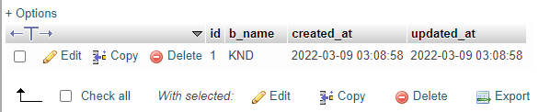

Figure 10 branch table example

Table 3 = > the [cfg_currencies](http://localhost/phpmyadmin/index.php?route=/sql&db=hms&table=cfg_currencies) table is responsible for holding the currency rates for the software, this currencies table is used to show the prices in the system according to the user preferred currency. (Eg: if the user selects dollars as his/her preferred currency then system will get the dollar rate from this table and convert the prices into dollars with the given exchange rate. Important: this table should be initialized once, then the system will update the rates automatically.)

Steps:

Go to cfg_currencies table and click on insert then, skip the id column leave it blank, insert a symbol to the c_symbol column like “Rs” “$” depending on your currency inserted, then add name of the currency to the c_name column. The name should be standard name like “LKR” “USD” not “Lankan rupees” or “Dollars” (the symbol and the name is directly important to the system to update the rates later so please add the standard names and symbols or contact evolve team for assistance)

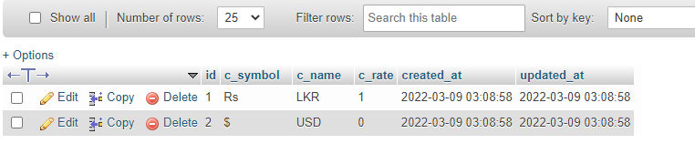

Figure 11 cfg_currencies

Table 4 = > The cfg_generate_ids is responsible for the format of the reservation ID / booking ID, this table can enable to include the year and month the in the booking and reservations and also to disable them.

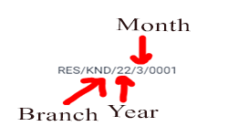

Figure generated ID

Steps: go to the cfg_generate_ids table and click on insert, then skip the ID column input field, then in id_year input if you wish to add the year in the reservation / booking id then insert 1 else if not 0 and add 1 or 0 to the id_month input field. (1 represents active, 0 represents inactive), then click on go to insert the record to the table. Your table should look as below.

(Please note that this table should only have one record, if this table has multiple records the system won’t work as expected)

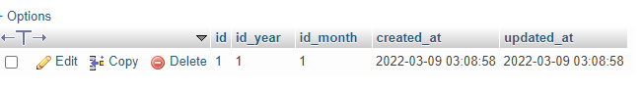

Figure cfg_generate_ids table

# Uploading the HMS system to the server / hosting

Now it’s time to upload the evolve hotel management system to the server, the system will be provided as a zip by the evolve team, as your network administrator to create a separate domain and assign it to a hosting, then the network administrator will provide a cPanel (dashboard to upload the system to the server) keep the credentials safe with the database credentials which was created earlier.

Steps 1 : go to the cPanel and login using the credentials given by the network administrator and then you will find a dashboard as below. Next click the file manager to go the files structure in the server

Step 2: navigate to the public directory in your hosting, If you are unable to find the public directory get assistance from your network administrator or contact evolve team for assistance.

Step 3 : then inside the public directory click on upload button a pop window will open, navigate to the location where the evolve hms zip is placed, then click on open which will upload the zip to that particular location.

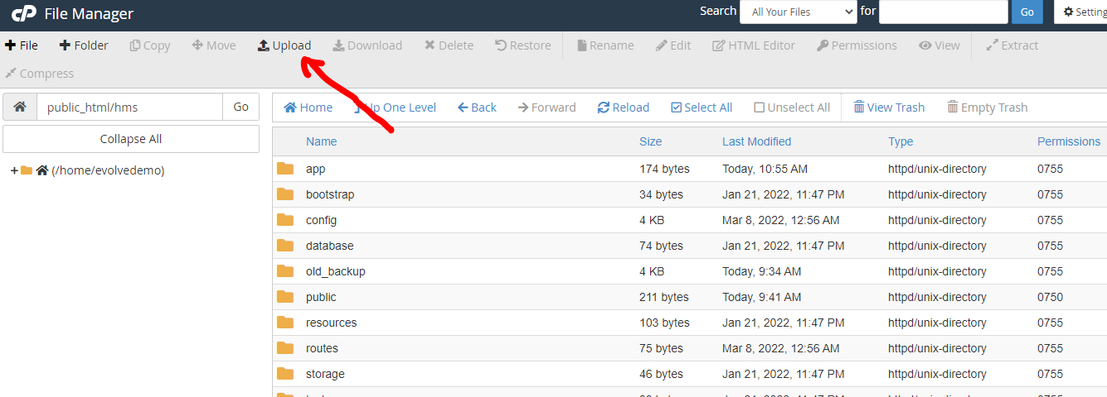

Figure upload the zip

Step 4 : next your folder structure should look like below image, now the system is uploaded to the hosting / server successfully we need to configure the system to work with the database. There is a file called. env. right click and click on edit then a text editor will be opened.

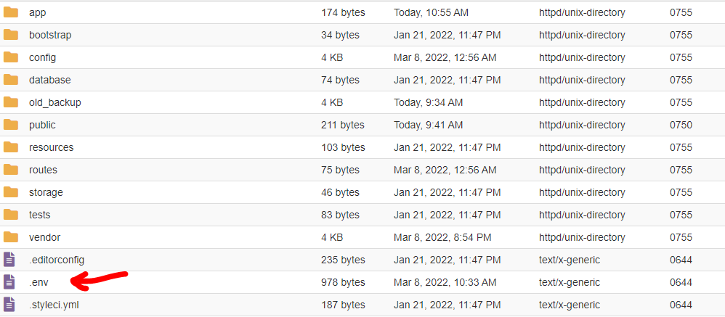

Figure config the env

Step 5: in the text editor change the DB_DATABASE to the database name that network administrator gave to you, then place the DB_USERNAME with the db. username and DB_PASSWORD with the db. user password given by the network administrator. Then hit on save to save the changes.

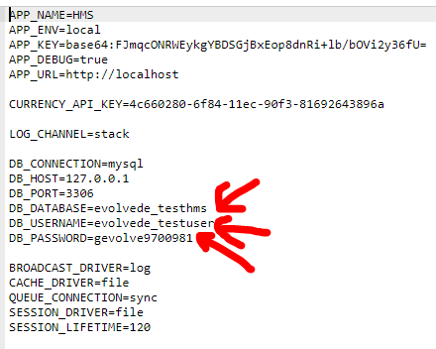

Figure environment variables configuration

Step 6: next go to the domain given my network administrator to access the system, the domain should look like www.example.com, when you visit the domain, the page should look like below. If not please contact evolve team.

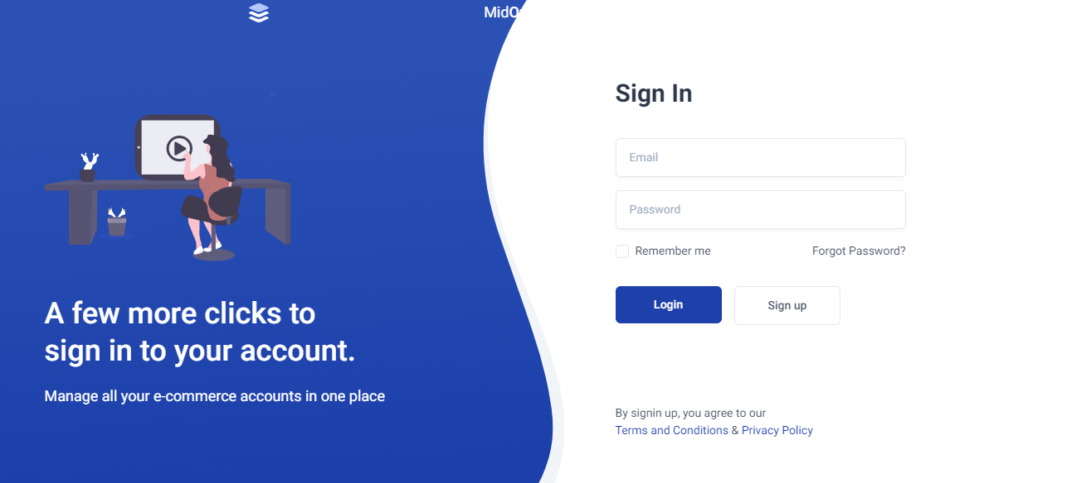

Stage 2 (system Usage)

# Dashboard

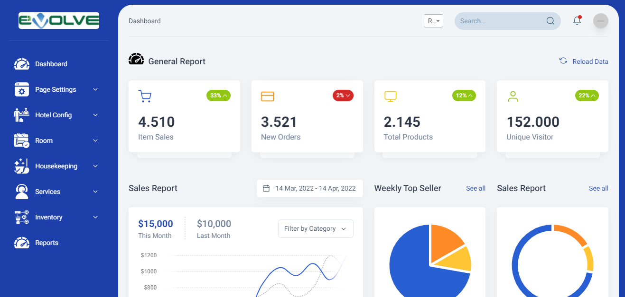

The dashboard will be the place where all the stats regarding the system is viewed to the user

## Basic Usage

This system has a similar layout through out the system, there are two main sections to consider. The navbar, and buttons

The navbar is by default in the right on the screen. You can use this to navigate to each and every page in the system.

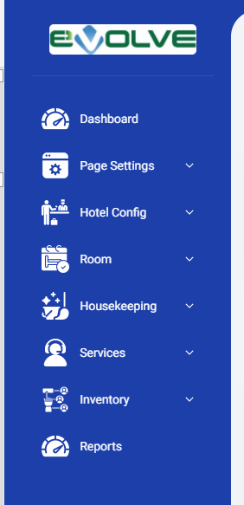

There will be buttons appear in some forms, these buttons are save, clear, and cancel, the save button will the save the data that you just enter to the system, clear button will clear the forms, and cancel button will redirect back you to the previous page.

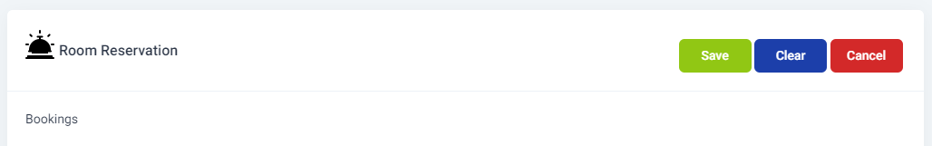

# Page Settings

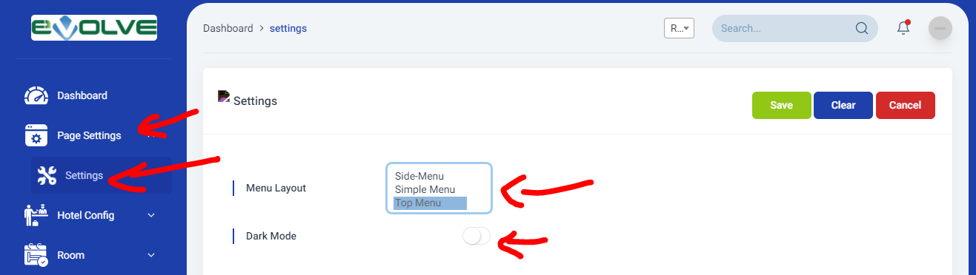

The page settings page is responsible for the change of navbar layout, the navbar layout has three options, side menu, simple and top menu, and also user can pick dark mode or light mode according to user preference, these settings will be saved and every time the user logs-in, these settings will be loaded. Each user can keep their own preference.

If you need to change the layout and theme, simply click on a menu layout from dropdown, then enable to disable dark mode by toggling the radio button and click on save button.

# Change Currency

For the easy user experience, this system has inbuild currency change system, the users are able to select from what currency the user prefers to see amounts in the system

(‘please note the when you are entering agent room rates, extra manual bills, you should enter them in LKR because the systems default currency is LKR and when the user change the currency it will be only used for display purposes only)

The user preferred currency type will be saved and when ever the user logs in the system will show bills and rates in his /her preferred currency.

To change currency when you are logged in in the system, simple click on the top right corner drop down as shown in the below image

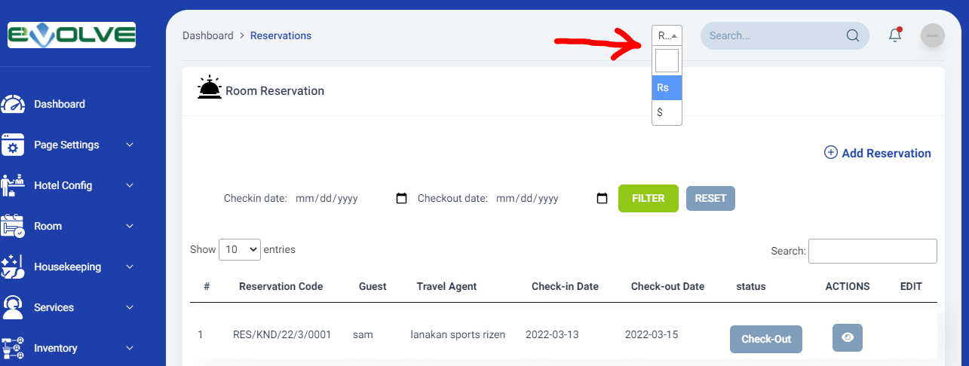

Then click on your preferred currency and the system will reload with your preferred currency.

Before start adding reservations and using the system, there are initial steps to follow in order. To configure this system the user should be navigate to hotel config menu pages.

# Hotel Config -> seasons

The user can define seasons in the hotel, the main use of seasons is to maintain specific room prices in specific seasons, Eg : winter season, summer season. In the seasons page on the right-hand side, you can see a table where list defined seasons is shown

On the left-hand side, the season add form is placed where the user can add a new season to the system.

To add a new season simply fill the form with a season code which can be easily remembered and a name for the season, then the important part the start date of the season and the end date of the season,

this should be defined each year, the system will automatically pick the season for the given reservation date so make sure the date range is set perfectly (if the reservation / booking date is search out of the date range the room rates will be not shown because the system can’t find a season for given date range) and not overlap with another season, for a particular date range there should be only a one season.

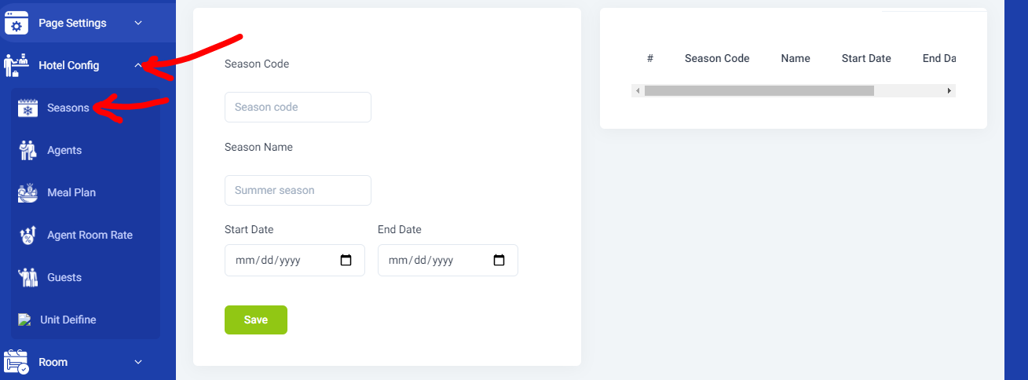

Figure hotel config season

To Edit a season, simply scroll to the right in the seasons table and click on action button, this will import the data to the form where you can edit them.

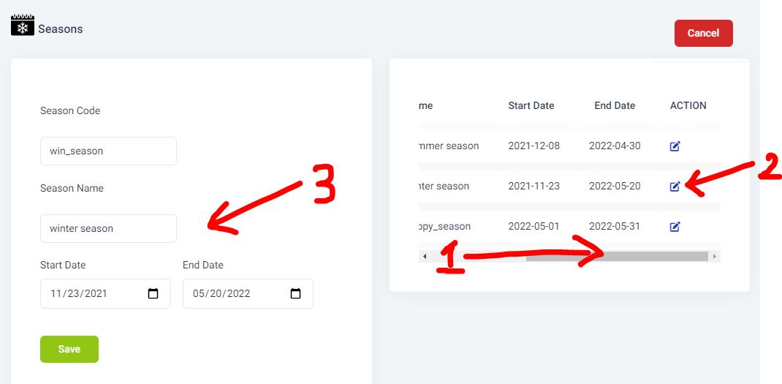

After the changes are done in the form and hit save button then that season data will be updated.

# Hotel Config -> Agents

Travel Agents are a critical factor in the hotel, all the travel agents registered with the hotel should be inserted to the system so that later can assign rates to the travel agents for a specific season.

Navigate to the Hotel Config -> agents page and you will see all the agents listed in a table, to add new agent click on Add Agent button.

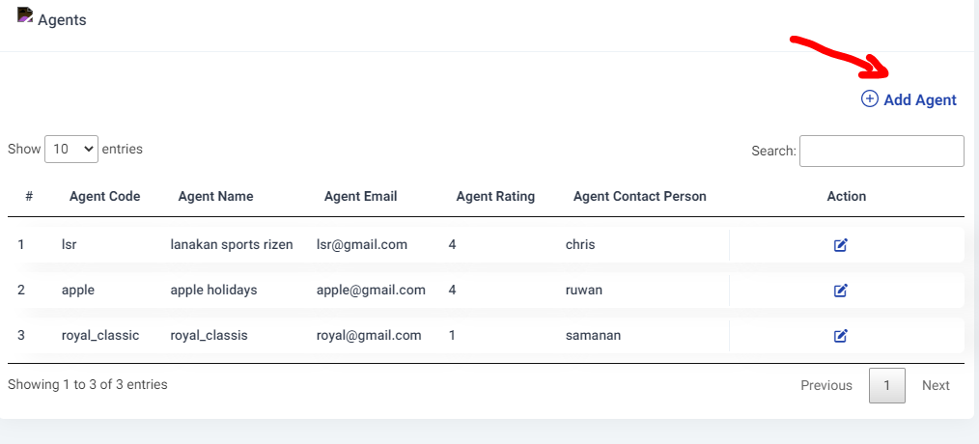

Then you will a page as below, fill the details in the agent form and click on save button to submit and then the agent will be added to the system.

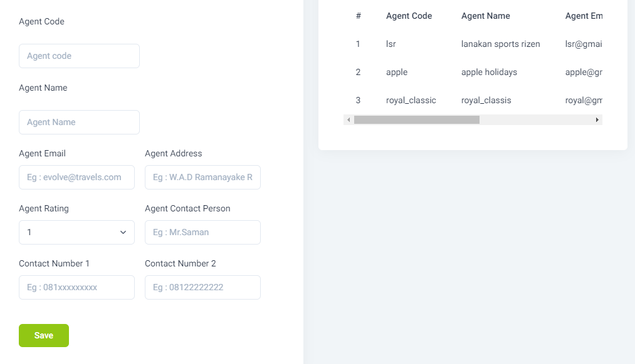

Figure agent add page

To edit an agent data simple go to hotel config ->agents page and click on action Edit icon to edit the specific user, the edit page will be opened with the data already filled so that you can do the changes and hit save to update.

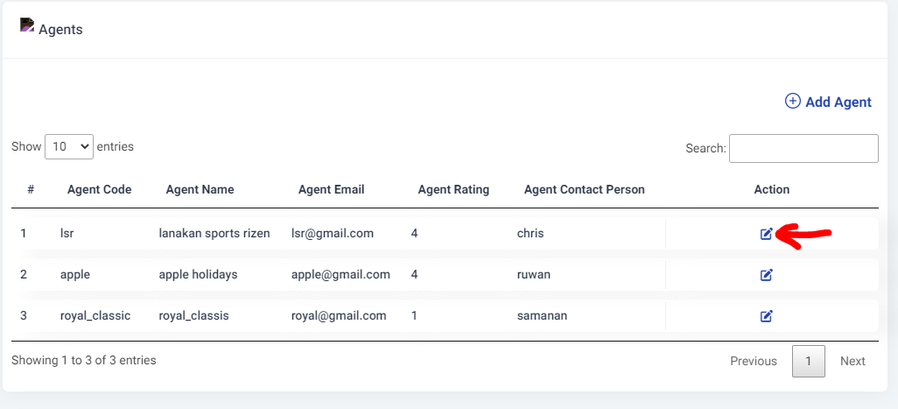

# Hotel Config -> meal plan

The meal plans BB/HB/FB/RO can be inserted to the system using hotel config -> meal plan page, you can click on add meal plan to add new meal plan and also click on action in the main meal plan page to edit those.

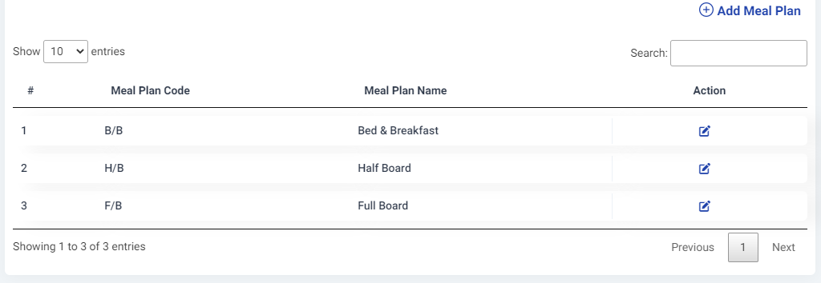

Figure meal plan page

# Room -> Room Category

This section is very important to proceed to the next section in the guide, In the hotel the rooms are been categorized based on the size of the room and depending on the occupancy of the room. Eg : Single, double, triple etc.

To add room categories to the system, go to Room -> Category page in the and you will see a page as below. Fill the form and click save to add new category and to edit a category click on the edit button of the preferred room category in the right-hand side table

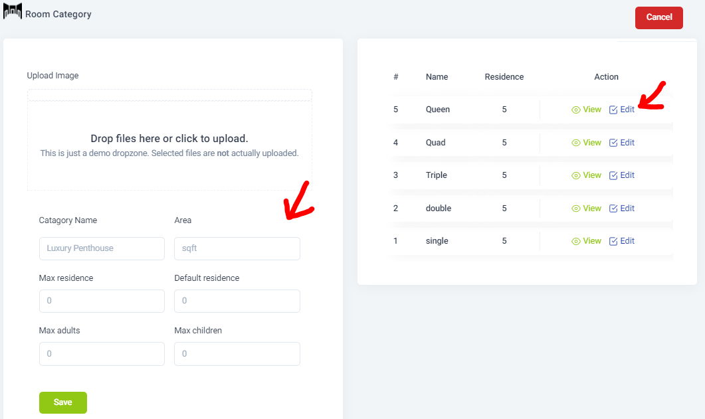

In this page you can insert images for a category, you can click on the images zone and file browser will be open to navigate and select an image, per once you can only select one image,

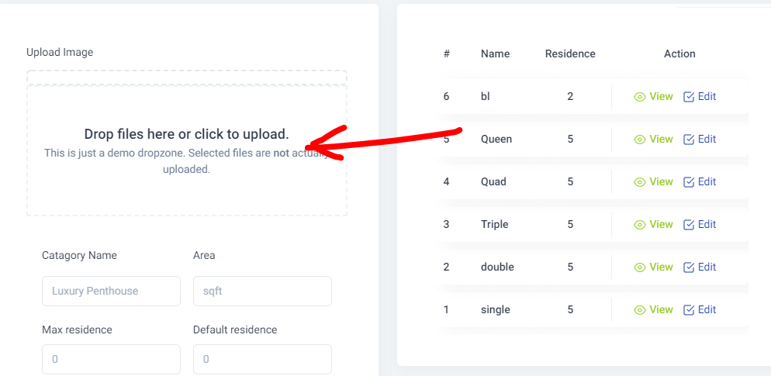

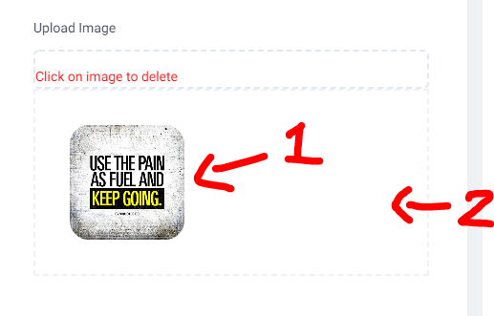

When you upload an image, you will find as shown above in the marker 1, if you wish to add more images just click on the area marked as number 2 in the above image. After you have entered images, your collection will be shown as below.

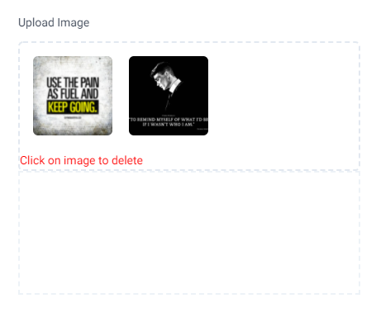

If you wish to remove an image from the collection simply click on that image then it will be removed.

# Hotel Config -> Agent Room Rates

This is the area where agent rates can be assigned to a specific season, (to add rates it’s a must to add seasons, agents, meal plans and also the room categories first)

To add the agent’s rates for specific season please visit hotel config-> agent room rate. Then you will see a screen like below.

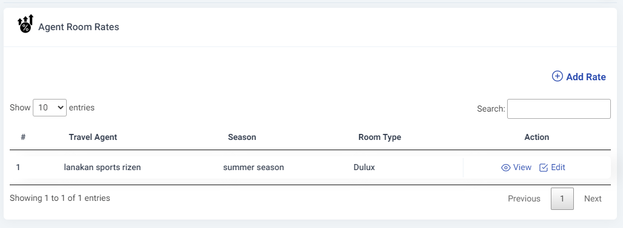

Here you will find add the rates for the agents for specific season listed, if the table is empty then click on add rate to add new agent season rate. Now if you have added the room categories, agents, meal plans, and seasons prior to the agent rates then you will see a page as below image is shown.

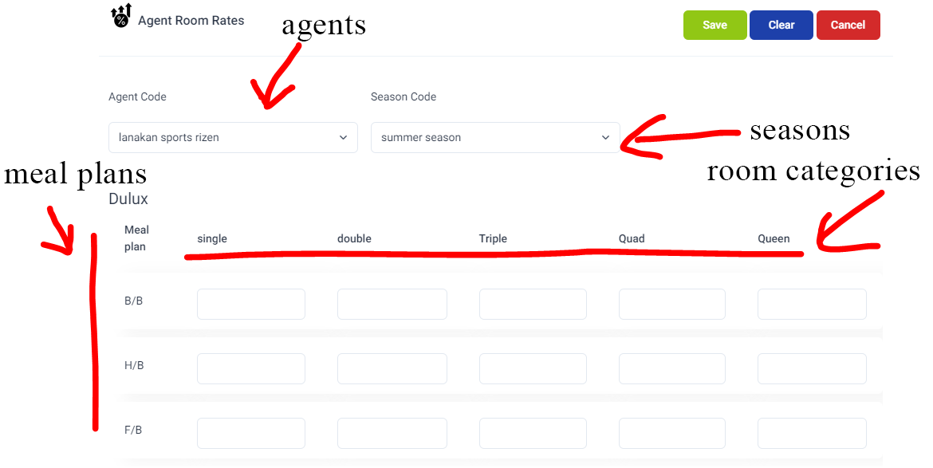

Figure 20 agent room rates

Select your preferred agent from the agents drop down and select the season in which the rates should be assigned, then in the below meal plan room category add the rates you preferred as below as below.

(Please insert the rates in LKR value, the default currency type is LKR)

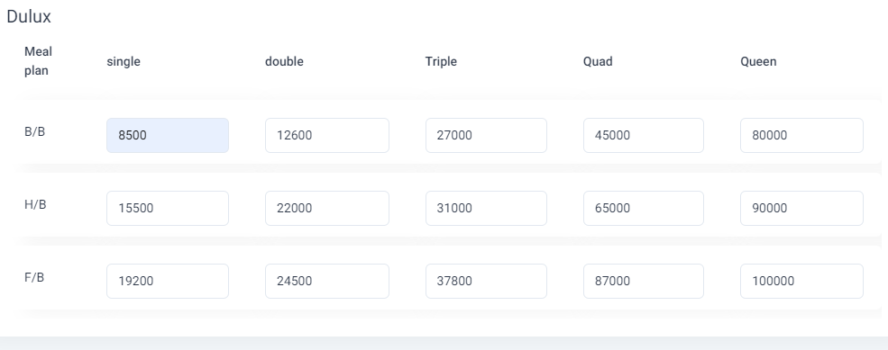

Now click on save to save the agent rates and after a success message popup you will be redirect to the main agent rates page where you can find the rates that you just add in list.

# Hotel Config -> Guests

This system can hold the hotel guests from all the reservations, there are two methods to add guests to the system, first method is to add the guests in the guests’ page, go to hotel config -> guests and you will find a page where all guests are listed. You click on add guest and fill the form to add a new guest to the system and to edit a guest detail in the guests list home page click on action in the particular guest row.

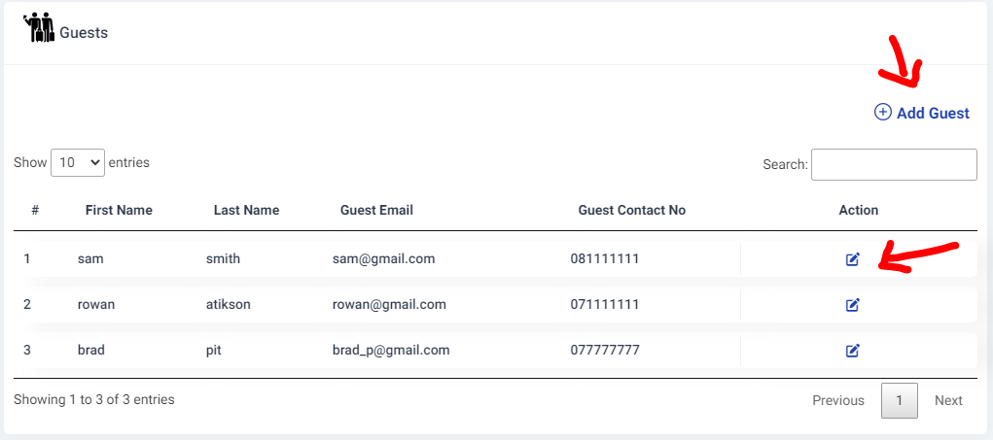

Figure 21 guests list

# Hotel Config -> Unit Name

The system has an inventory management too, so to use the inventory management system the units which are used should predefined, to define the units please visit hotel config -> unit define as you will be able to see a page like below

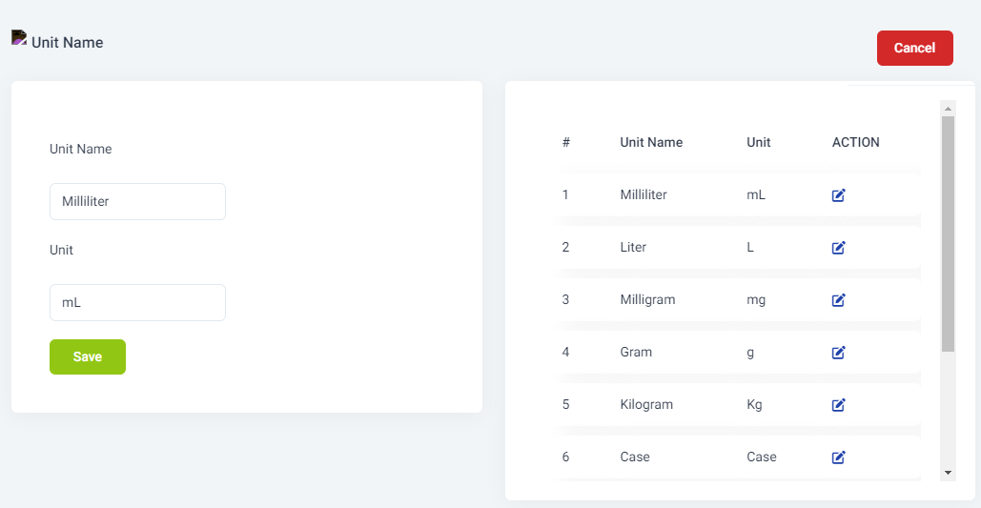

Figure 22units

# Rooms - > Room Type

Room type is the page where you can define the room types like deluxe standard etc. To visit the room type page simply go to Room -> room type

# Room -> Rooms

The room page is one of the major important pages in the system, this where the user can define the rooms, to add rooms please visit Room -> rooms and you will see the page as bellow.

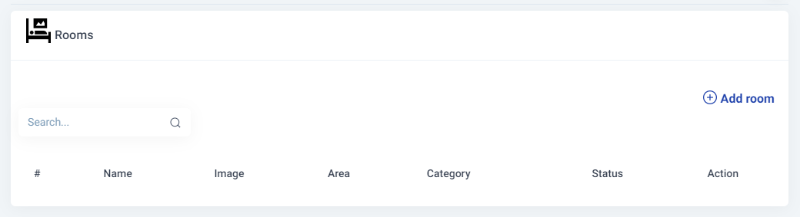

Figure 23 Rooms page

To add a new room just click on add room then a page will show with a form as below,

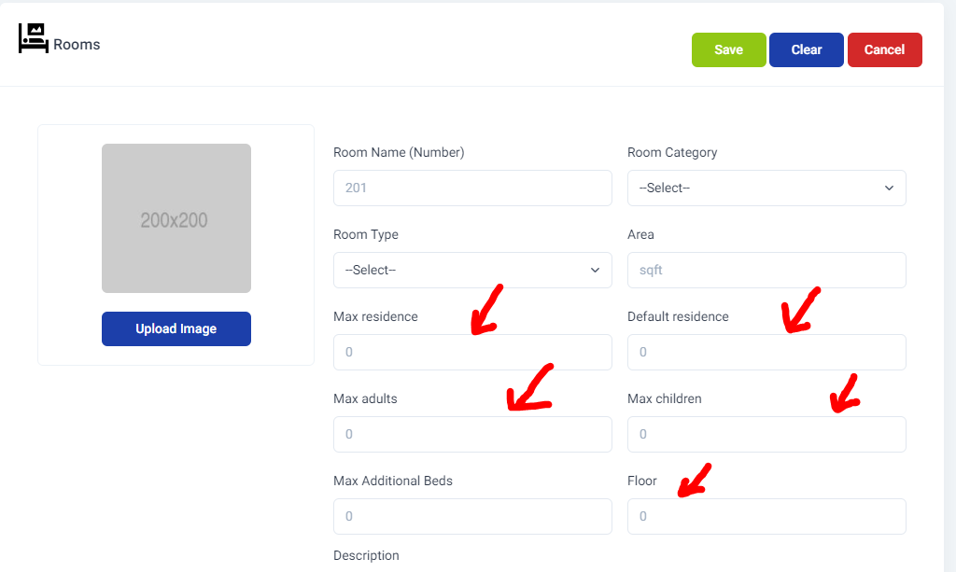

fill the room form with the preferred data and the room image is not compulsory, it is important to note that the max residence, default residence, max adults, and max children should be placed accurately because when check-in a reservation there will be an option to add the guests for each room

(For an example is you defined 1 adult instead of 2 in a double room by mistake when you check-in the reservation if you try to add 2 guests to the double room the system wouldn’t let you add two guests to that room.)

The rooms have Its own facilities sometimes, when you are creating a room in the system, you can mark the facilities to inform the system that particular facility belongs to that room , you can just simply put a tick Infront of the facility. (See below image for more info)

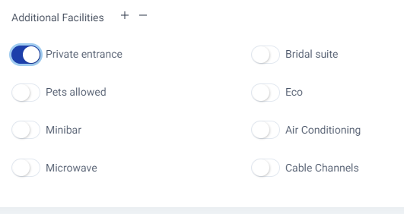

Figure 24 additional facilities

If you need to add an additional facility to this room that is not mentioned in the additional facilities section, just click on the plus sign and a new input box will appear to add a new facility, you can click on add sign any number of times to add facilities.

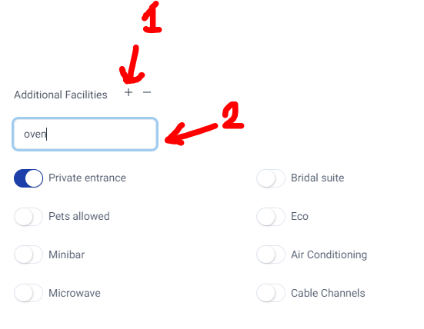

Figure 25 additional facilities add new

After adding facilities, you are able to go ahead and click on save which will save the room and after the success message you will be redirected to rooms page and your rooms list will be shown.

# Rooms -> facilities

This is where the room facilities are defined, which will be appear in the add new room area, you can just add a name click on save to add facilities. To go to the page, navigate to Room -> Facilities

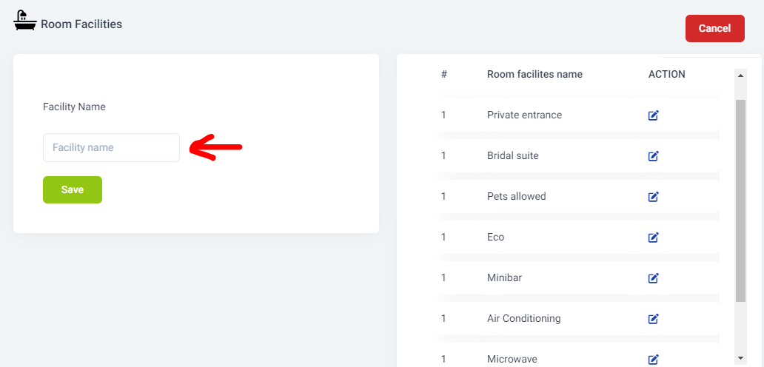

Figure 26 room facilities add



# Room -> Booking

This page will let you add bookings to the system, first go to the Room -> booking and you will page as below.

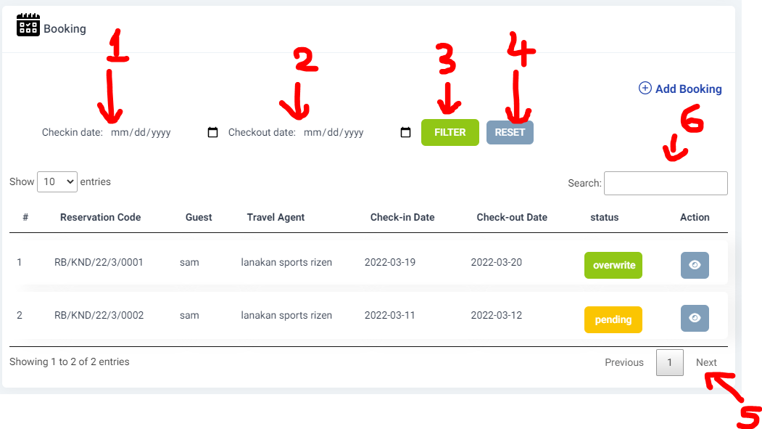

You can find the list of booking in this page, at the moment your table will be empty, you can filter the booking by date, to filter the bookings by date just pick the check-in date in the date picker (mark as 1 in the image) and also pick the checkout date from the date picker (marked as 2 in the image) and click filter, the page will be filtered and show booking only in the given time.

To reset the filtered dates and to show all the bookings click on reset button (marked as 4 in the image)

If you need to filter by a keyword, the keyword can be a booking id, date, travel agent name, just type in the input box and it will be auto filtered (marked as 6 in the image).

To add a new booking just click on add booking button. Then you will find a screen as shown.

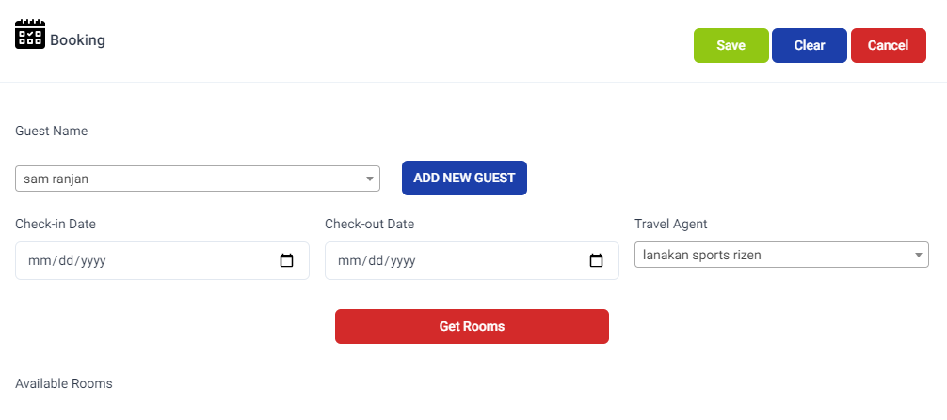

When adding a new booking, you can select a guest to which the booking is placed, you can search the drop down or select by clicking on it.

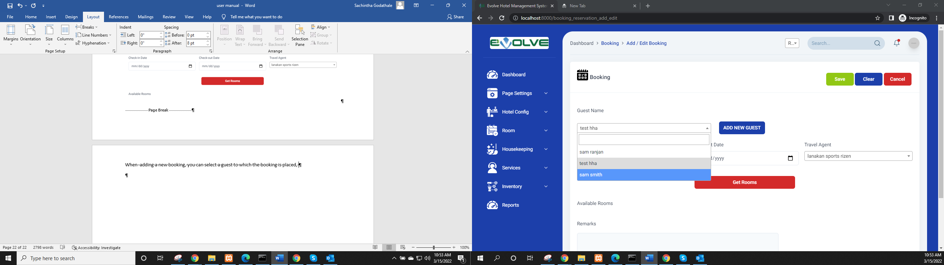

If you need to add a guest while creating a booking then click on add new guest button, then you will get a popup like below.

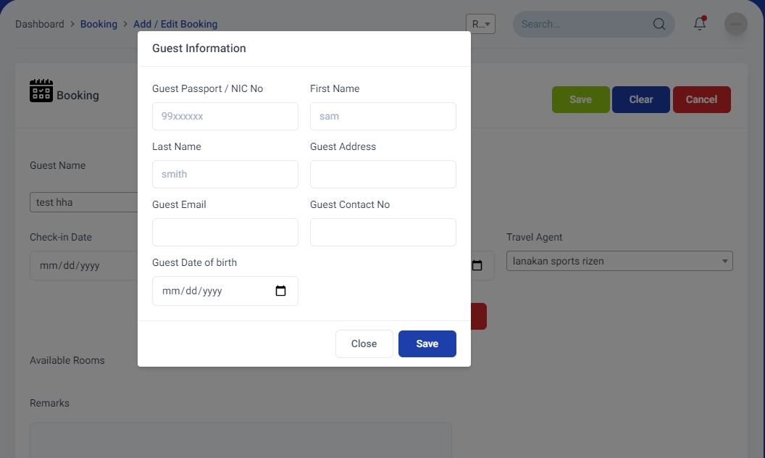

If you fill the form and click save then it will temporarily store the guest data and closes the popup then you can start adding the booking details as usual.

You can insert a check-in date and check out date and select a travel agent from the dropdown and click on get rooms button, then it will load the rooms available in the given check-in check-out date range.

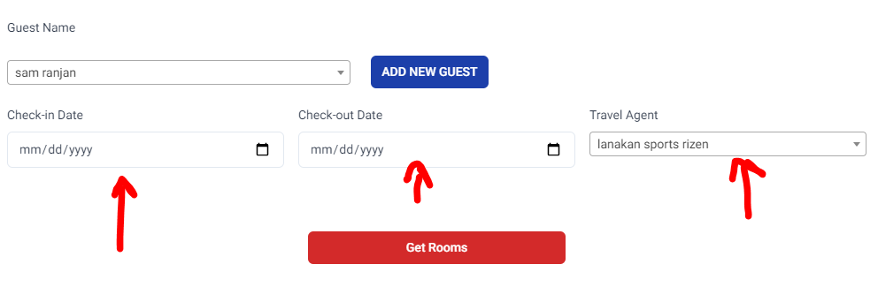

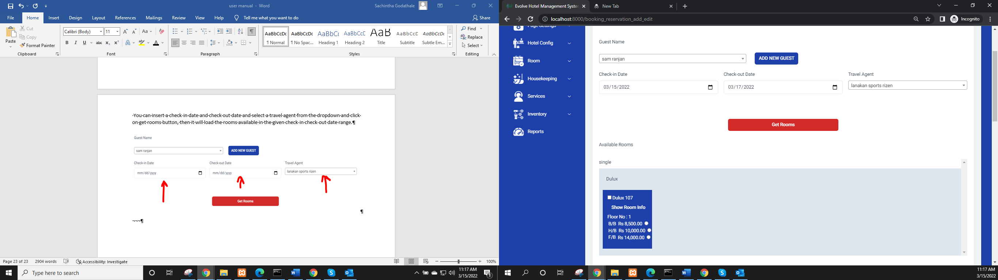

As shown in the below diagram, after the get room button is clicked the available rooms will be shown and the room will be categorized depending upon the room category and room type, so in the below image the marker 1 shows room category, and marker 2 shows the room type. The marker 3 shows the room.

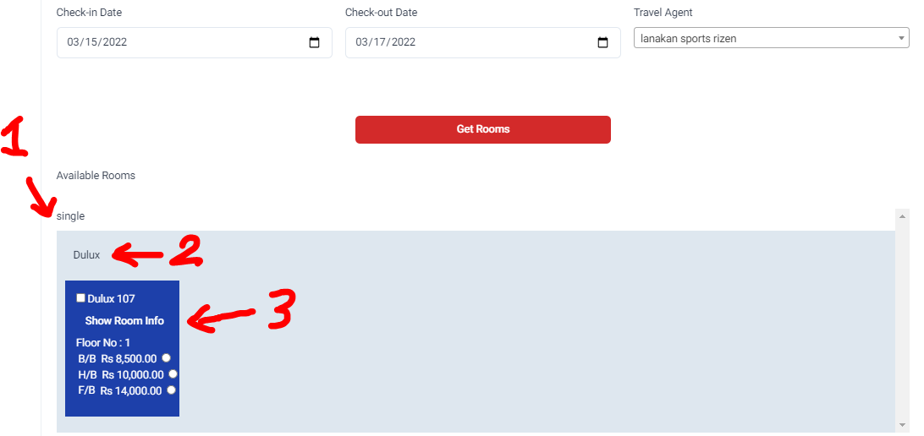

You check on the checkbox in left to the room number, this will let know the system that the particular room is chosen, next each room can have different meal plans, so below the room number and show room info there are listed meal plans available to the selected travel agent, you can click one of them for each chosen room.

Now your room should look like below image

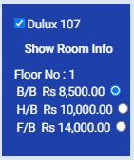

If you click on show room info button a popup will appear, this popup contacts the room category, room type and room max adults and some information regarding that particular room. And in that popup, you can find an additional facilities list, here you can tick or untick facilities, these facilities will be applied only for this reservation rooms. After choosing the rooms click on save button a new booking will be placed.

# Room - > Reservation

Room reservation page is the place where confirmed booking are placed, there are two ways to place a reservation, method 1 is to place new reservation, method 2 is to convert a booking into reservation. We will take about it later in the documentation, for now we will talk about creating a new reservation. You can visit the room reservation page by navigating to Room -> Reservation.

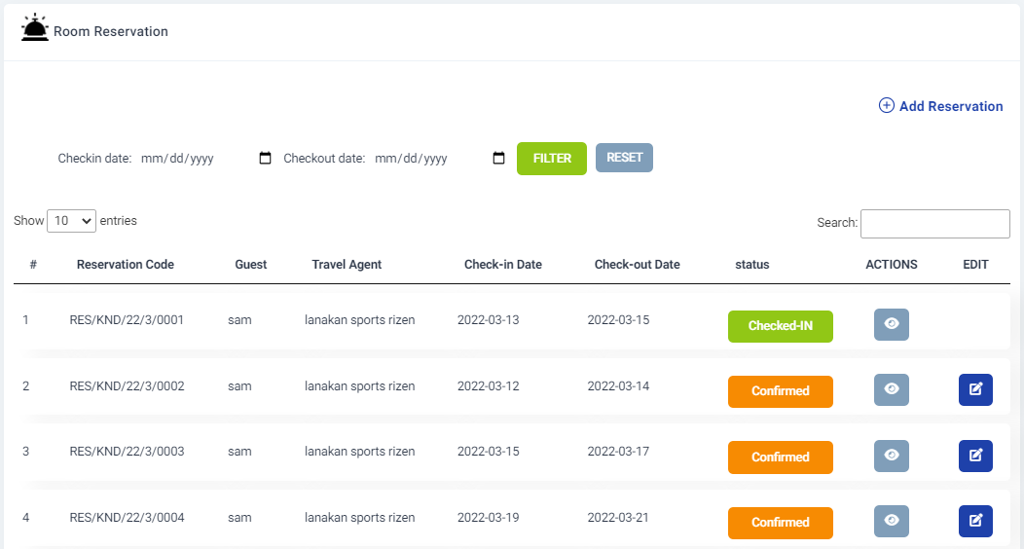

## Adding a reservation directly

It’s pretty straight forward, just navigate to the add reservation page, just like a booking fill the check-in check-out dates and travel agents and click on get rooms. Then select the rooms, meal plans and click save to make a reservation.

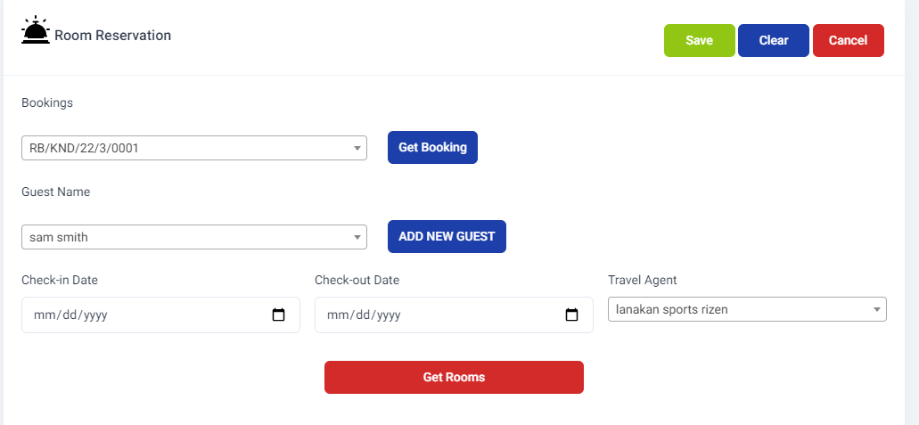

## Convert a booking to reservation

Go to Room -> Reservation Add Reservation page

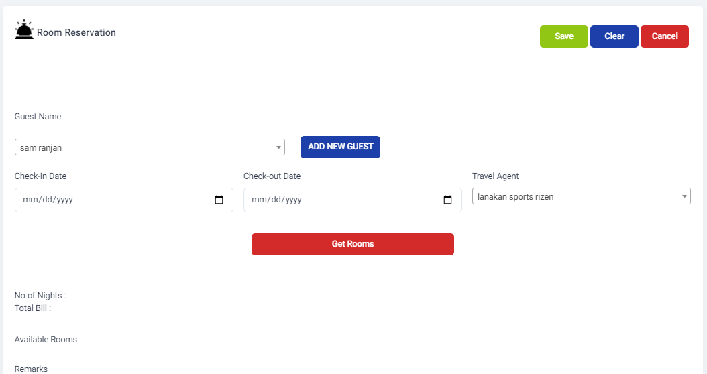

You will find a similar page like booking page, but this page has some additional features, in the below image you can find that there is a section appeared as bookings, this section will appear only if there are bookings available to be converted to reservations. You can select a booking from the drop down and then click on get booking button.

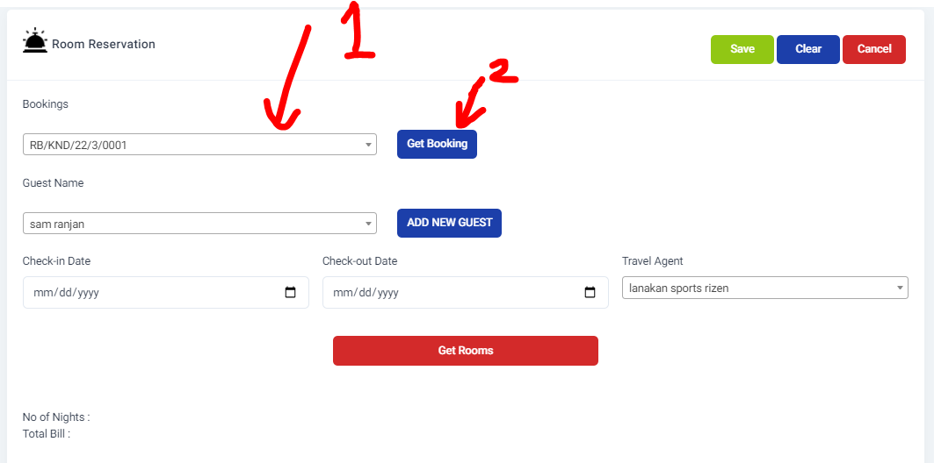

When you click the get booking button the reservation page will be changed as below.

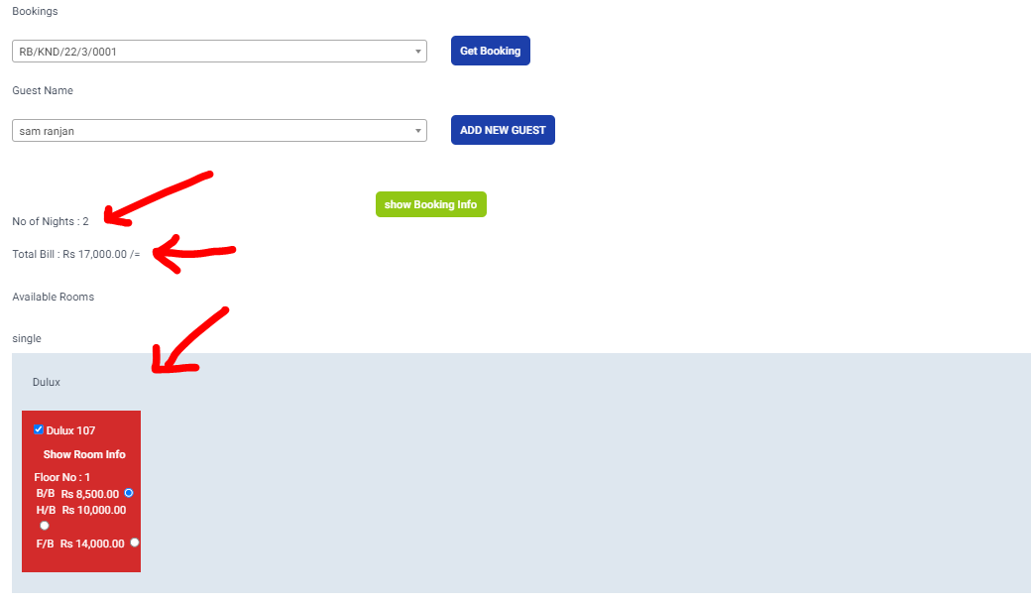

In the reservation page the no of nights will be shown, then total bill amount will be shown, if you need to see the booking information you can click on show booking info button and a popup will appear as below

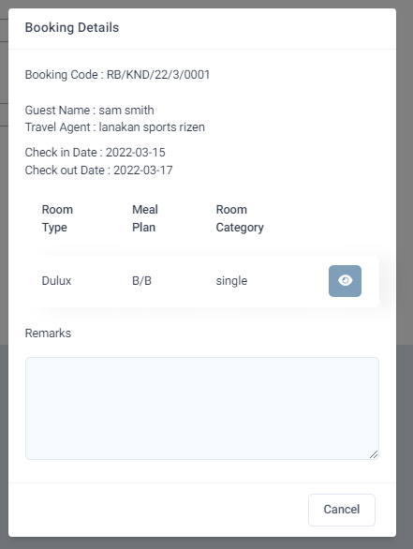

In the pop will show the all the details regarding the booking.

After closing the popup you can scroll down and see that the rooms booked for this booking plus vacant rooms. The booked room will be marked in red with that rooms meal plan is selected,vacant rooms are showed in blue

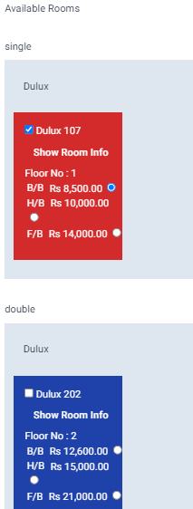

Here you can add more rooms to the booking or do amendments and click on save for the form to submit so that the booking will be converted to a reservation.

### Show overlapping bookings when adding a reservation

There are situations where there are bookings for a particular date range, for instance you are going to add a new reservation for date range and you need to be notified that for this particular date range there is a booking. So below scenario is based on this theory.

Just go the add new reservation, then add check in date and checkout date, then select a travel agent and click get rooms button, then the available rooms will be shown to add for the reservation, if there are vacant rooms then they are been shown in blue, if there are bookings for a particular room in particular day then it will be shown as below.

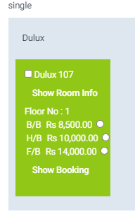

Vacant Room will be shown as below

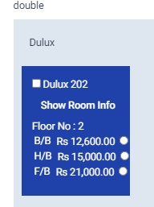

If there is a booking you can check from what booking this room is booked by simply clicking on show booking button on the booked room

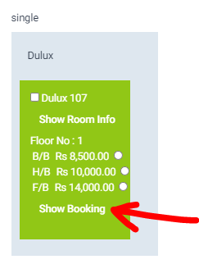

If you need to include the booking room too with the reservation then tick on room and tick on meal plan, then that room will be included in the reservation and after submitting the reservation that booking which was overwritten its status will be changed to overwritten.

If you go to the booking page and you will see the overwritten status.

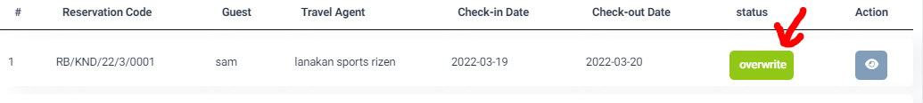

Later if you need to convert that overwritten booking to a reservation then simple to reservation add page then select the booking from the booking dropdown then click get booking. This time a error popup message will be shown mentioning that the booking is been overwritten and assign a new room to this booking as below.

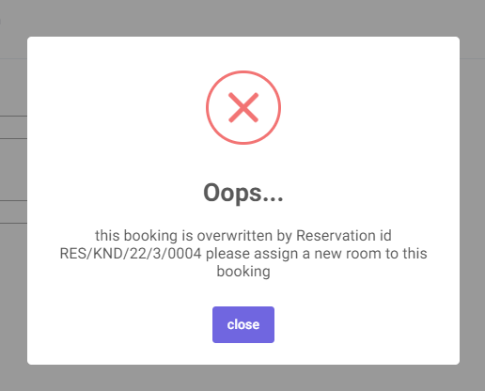

You can simple close the message, then select a vacant room and then click on save button. Then the booking will be converted to the reservation.

In the room reservation main page you can click on view in action, this will open a popup showing the reservation details and room rate info, if there are additional bills, and if you have defined extra charges in the [cfg_bill_charges](http://localhost/phpmyadmin/index.php?route=/sql&db=hms&table=cfg_bill_charges) table then it will be shown and the final total bill

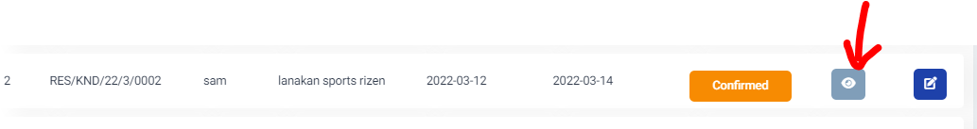

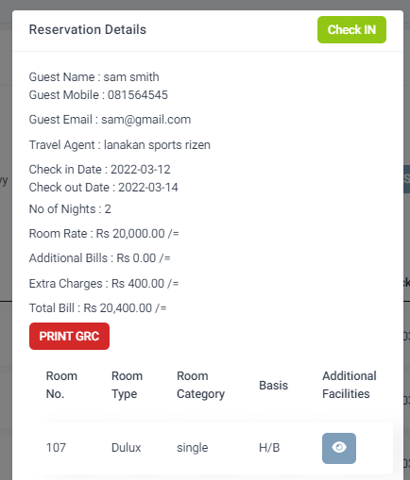

In the popup there is a button called print grc, when you click on it, the guest registration card will be opened as a new tab as shown below.

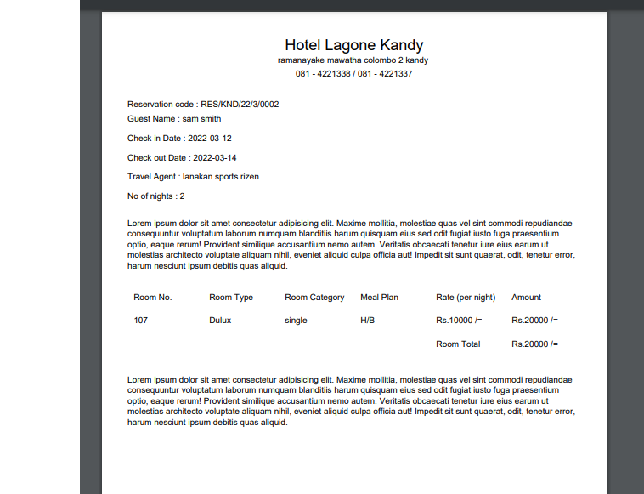

You can print this document or save to a pdf using the buttons marked in the below image

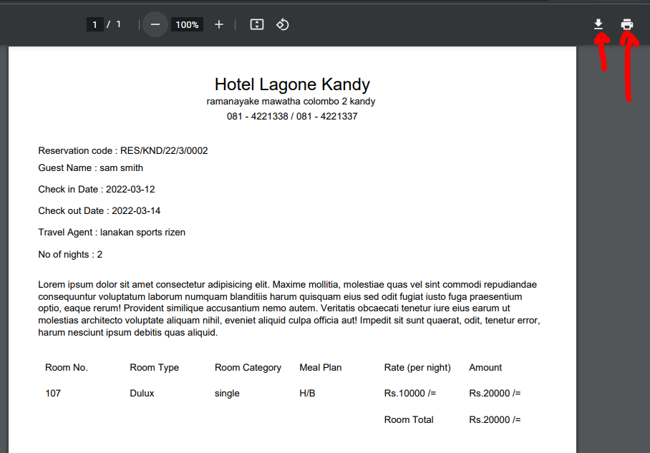

## Reservation EDIT

If you need to edit a reservation, simply click the edit button on the reservation in the particular row, then edit reservation page will be opened.

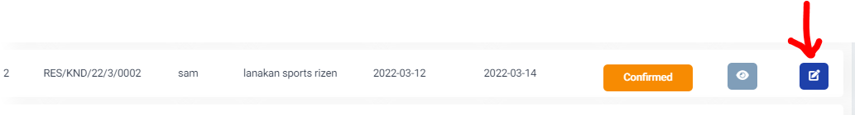

You will see the reservation related data is already filled and the rooms have shown for the particular reservation, here you can add or remove or change meal plans, rooms, additional facilities of rooms, and do the final save button click to submit and amend the changes.

However, let’s say there is a reservation for room 103 from 15/03/2022 to 17/03/2022 then another reservation from 19/03/2022 to 22/03/2022 for the same room. the client from the reservation second requests the day of check- in to be amended to 16/03/2022, then there will be an overlapping between two reservations for the same room.

Then when you submit the page to amend the reservation there will be popup as below

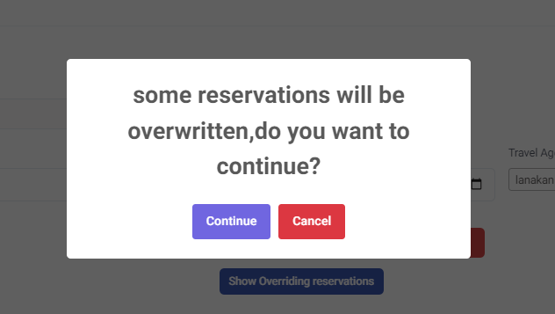

Here you have two options, you click cancel and there will be a button saying show overriding reservations, then click on the button and popup will be appear showing which reservation is overlapping and when you click on it you can view those rooms, or in the popup you can just press continue and overwrite other reservations and forcefully add a room for this reservation.

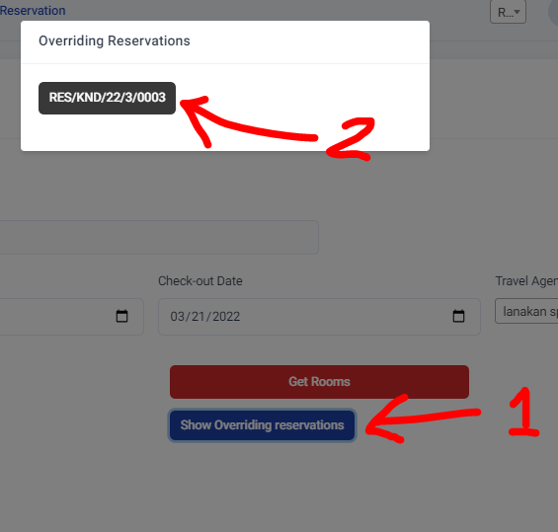

If you continue that means to forcefully do the overlapping reservation, at that point you in the reservation page the overwritten reservation will be shown.



Now due to reservation is amended with forcefully, another reservation is overwritten, to solve this you need to click on the edit button of the overwritten status reservation.

When you click on the edit button as previous the reservation edit page will be displayed with the already filled data. When you scroll down you will find the rooms section, in there you will find rooms marked in red that belongs to this reservation and rooms marked in grey color, which are the rooms overwritten by another reservation. The vacant rooms will be shown in blue.

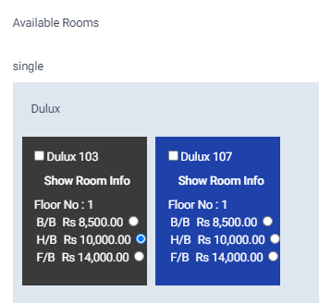

Here you can assign another room to the overwritten room (marked in grey), and also if you wish that this reservation particularly needs the overwritten room then, tick the grey color room and click on submit, this will undo the overwritten status and mark as confirm.

## Check-in Reservation

Click on the view button of the particular reservation, and on the popup in top there is a check in button, click on it and you will be redirected to reservation guest list page, this page is used to add the guests lists for that particular reservation,

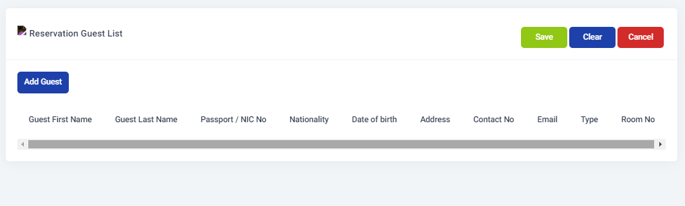

To add a guest to the reservation, click on add guest button then a popup will appear, fill the guest details and importantly select the type of the guest as adult or children, (as you can remember when adding rooms, you entered the no of adults and children can be allocated to that particular room)

You can get an idea about the room’s adult and children count in the popup guest room assignable count table

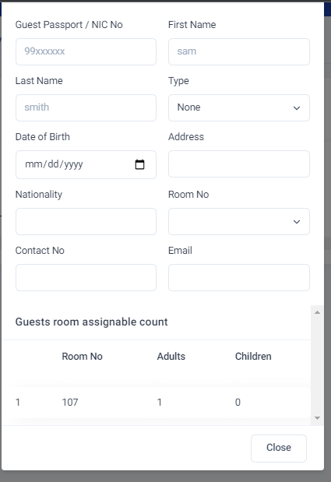

After adding the guests, you can view the guest list in the table in same page as shown below

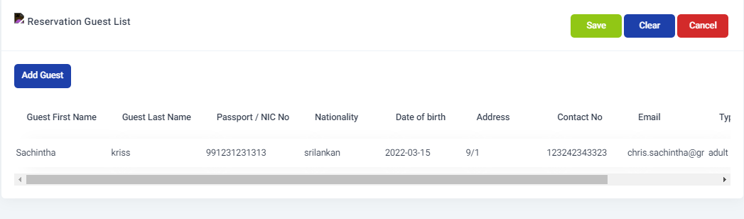

After you added the guest list then click on save button, this will check in the reservations and you will be redirected to the main reservation page with success. The checked in reservations will be shown in the table as below.

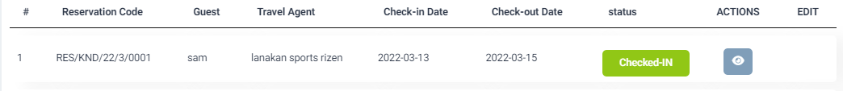

## Add manual bill to reservation bill

If there are manual bills to a reservation, you can manually add them in the system, this step is fairly easy, just go to the room->reservation page then click on view action button get the reservation details popup (in order to add manual bills, that particular reservation should be checked in).

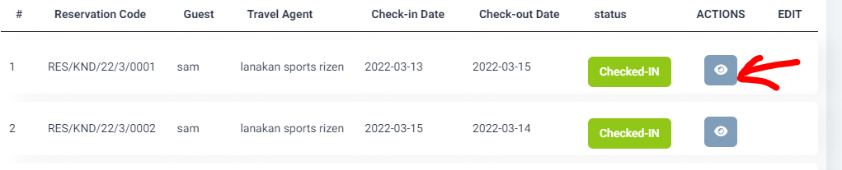

Next click on add manual bill button and then you another popup will be appeared,

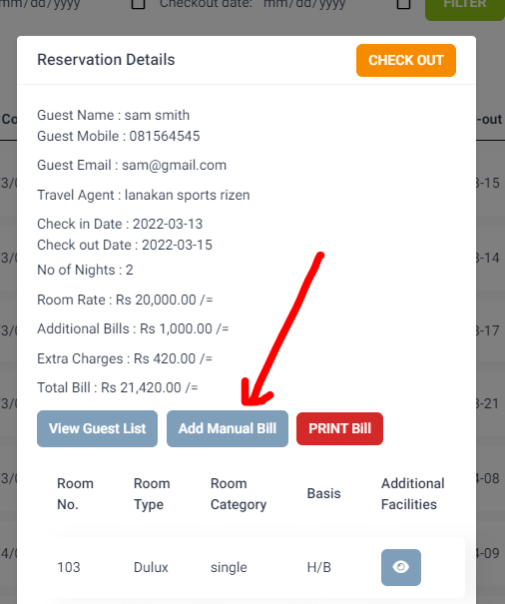

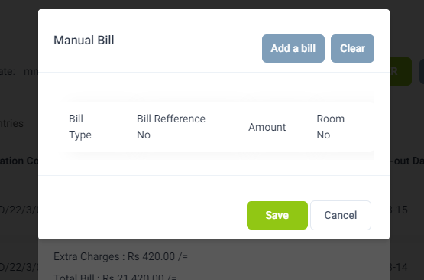

As shown in the above image that modal can be used to add bills as bulk to the reservation, simply click on add a bill button to add a new bill a row inside the table will appear as shown

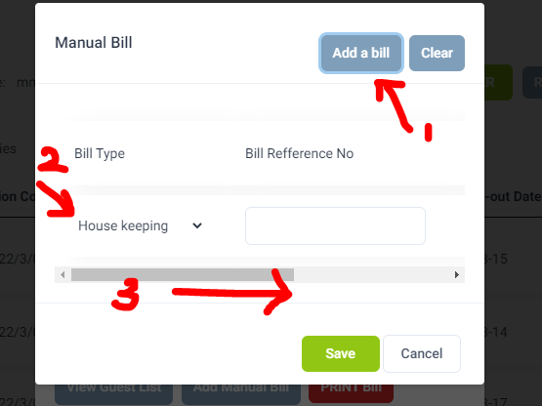

You can first select a bill type, there are mainly 4 billing types as housekeeping, additional service, KOT BILL, BOT BILL, then add the bill reference number which is the bill number of your manual bill, then scroll right and add the amount(LKR) in the bill.

Next choose a room from the drop down to which the manual bill belongs. If you need to add another bill just simply click on add a bill button again, or if you need to clear then simply click on clear button. After bills are added click on save to add the bills to the reservation.

After adding the bills to the reservation, in your reservation details popup you can find total of extra bills as below

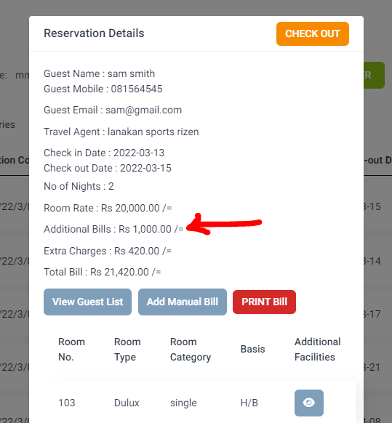

## Printing bills

You can view bills in the reservations, to do so please visit Room -> Reservations and click on view reservation details and the popup will appear. Depending on the status of the reservation the print bill button will be changed as shown below.

### Reserved Status

When the reservation is in the reserved status, you can view GRC by clicking on the PRINT GRC button in the reservation details.

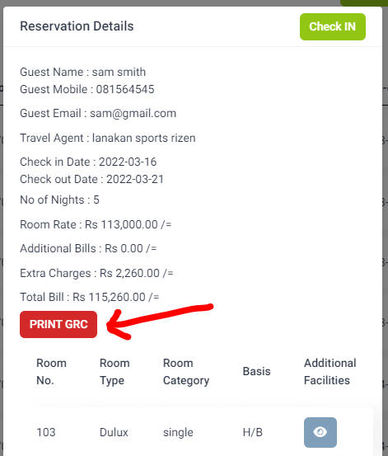

### Checked IN Status

When the reservation is in checked in status you can find a print bill button, here the room bill will be printed with all extra charges added.

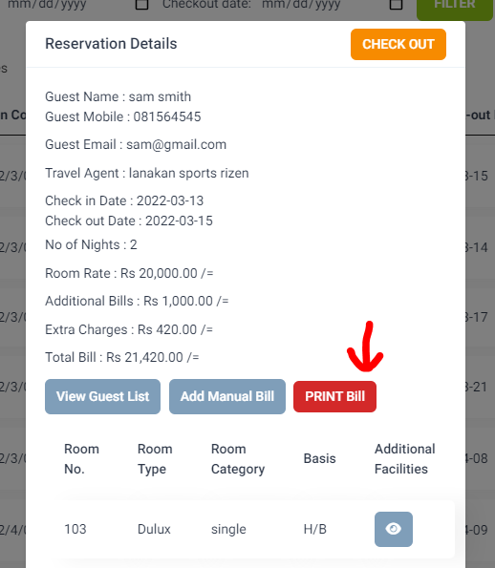

## Checkout Reservation

To checkout a reservation, simply click on the reservation details view popup and on the top corner click on the checkout button, then you will be redirected to checkout page of the reservation.

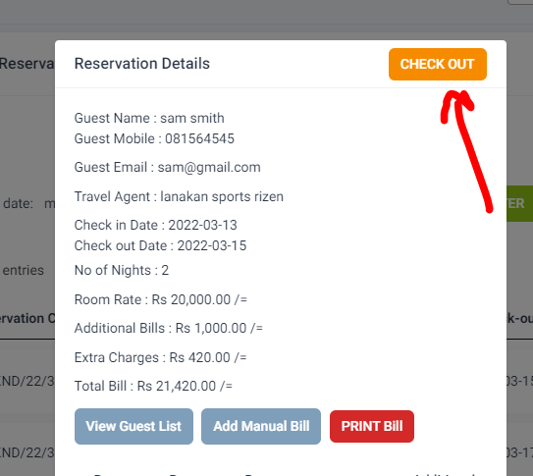

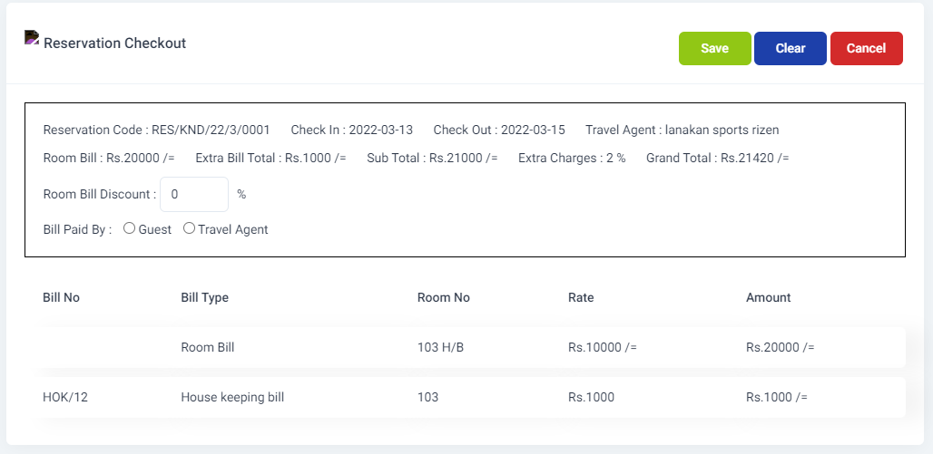

In the page you will see the all the bills related to the reservation are listed in the table below, and also information such as room bill amount, extra bill total, subtotal, extra charges, and grand total will also display.

In the page before checkout, you can give a discount for the reservation as a percentage, the percentage that you provide will be reduced from the total room bill but not from the total bill.

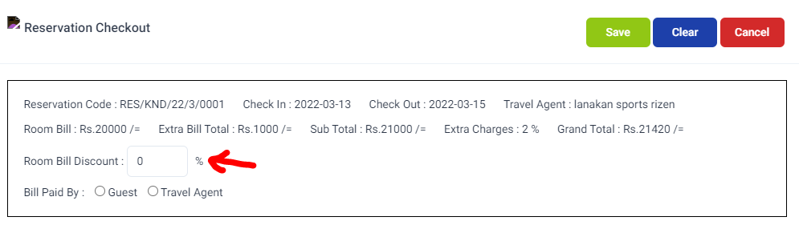

There are situations where the final bill will be paid by guest or travel agent, so to choose who pay the bill, please click on guest or travel agent radio button, then click on save to check out the reservation.

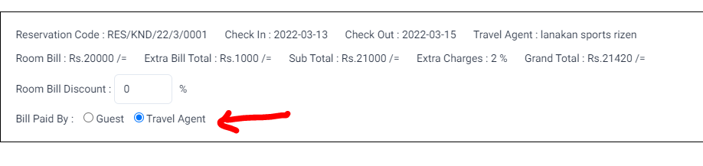

After checkout is successful you will get a message saying the checkout is successful and also in the reservations list, the reservation that you just checkout will be shown as below.

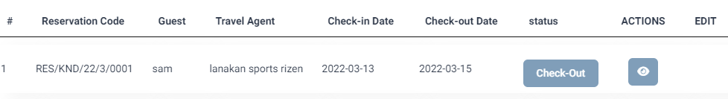

# House Keeping

# Services

## Inventory

# Reports

## Daily Forecast

This is the page where you can get the list of all the reservations and the details like tonight dinner packs count, tomorrow breakfast packs count, etc. on a particular day. this report is useful for the hotel function daily. To view daily forecast just simply go to Reports -> Daily Forecast

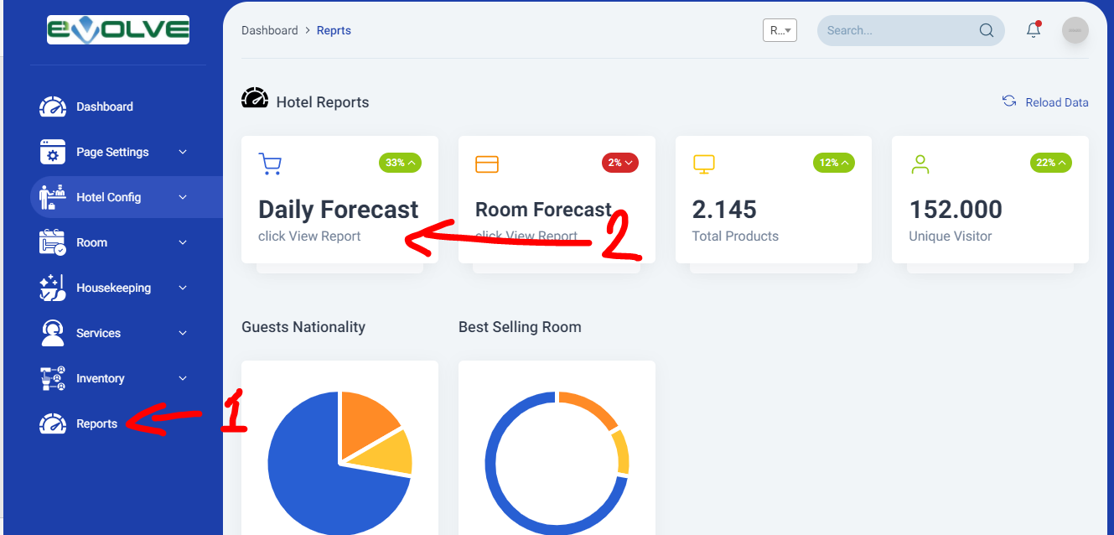

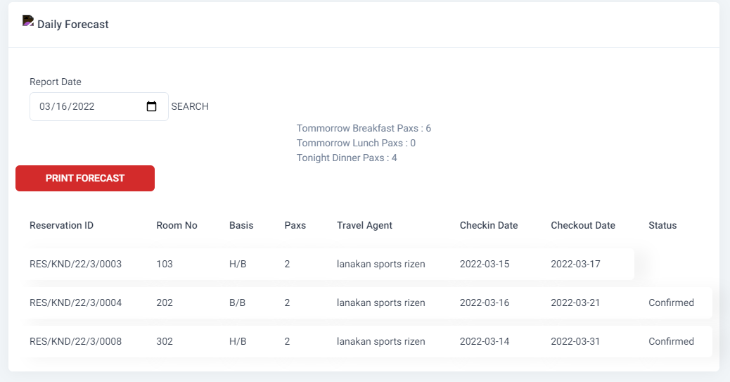

When you visit the daily forecast page normally the daily forecast will be shown to today’s date, if you wish to change the daily forecast date, simply change the date in the report date input and click on search button to view that day forecast.

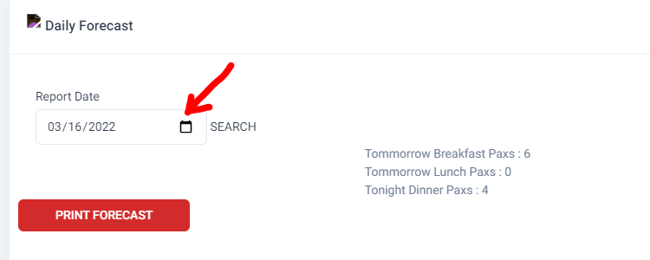

### Print Forecast

Simply click on the print forecast button, then it will open a pdf in new tab and views the forecast. As below

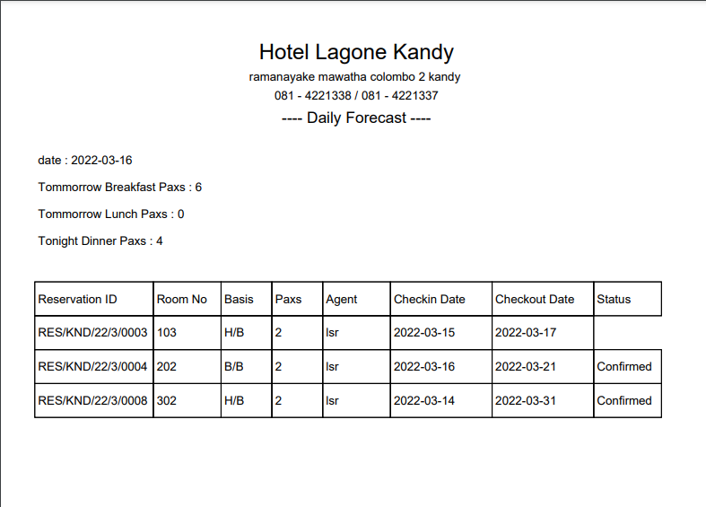

## Room Forecast

Room forecast is the room allocation for a given period depending on the booking and reservations, to view this report simply go to reports -> room forecast and you will see a table as below.

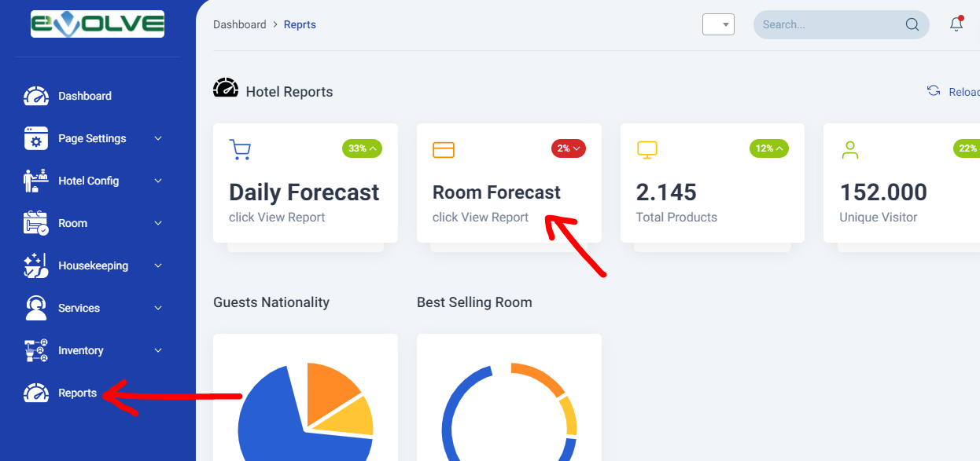

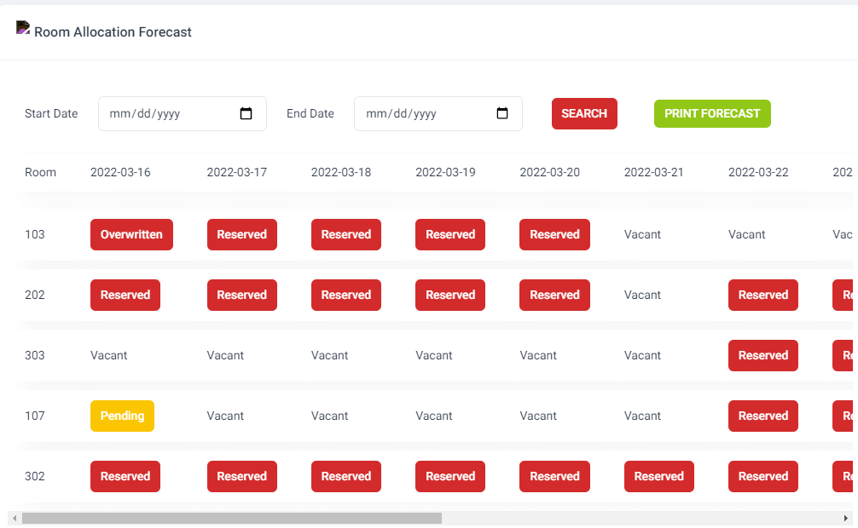

When you visit the forecast page you will see the room allocation distribution in a table, a date range will be selected already, that is the today’s date and 14 days ahead. If you need to change the date range simple change the start date and end date in the input tags and click on search button, then the room forecast for the given date range will be shown.

if you need to know for what reservation or booking on a particular day the particular room is reserved or booked, then it simply click on the block which is marked on the particular day for particular room and a reservation details will be popup

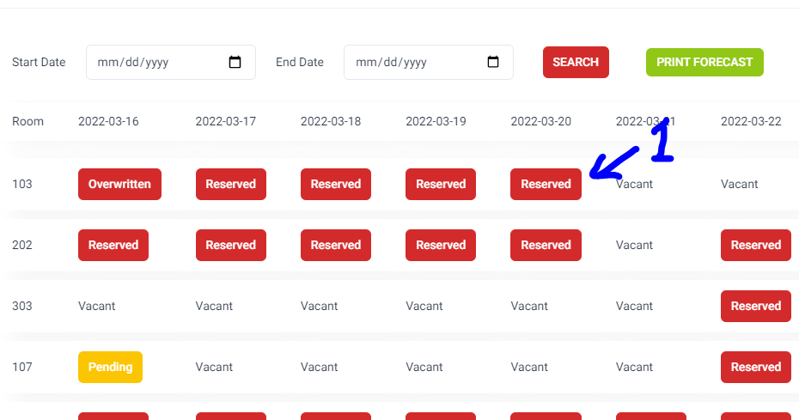

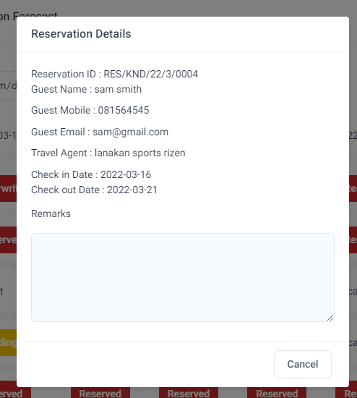

### Print room forecast

After selecting the date range or you can keep the same date range when the page first loads you can simply click on print forecast button and a new tab will open and shown the room forecast

